Task 7

1.

package guvitask ; import java.util.Scanner;

public class DivisionHandling {

public static void main(String[] args) {

Scanner scanner = new Scanner(System.***in***); try {

System.***out***.print("Enter the first number (dividend): "); int dividend = scanner.nextInt(); System.***out***.print("Enter the second number (divisor): "); int divisor = scanner.nextInt();

int result = dividend / divisor; System.***out***.println("Result: " + result);

} catch (ArithmeticException e) {

System.***out***.println("Error: Division by zero is not allowed.");

} catch (Exception e) {

System.***out***.println("Error: Invalid input. Please enter valid integers.");

} finally { scanner.close();

System.***out***.println("Program execution completed.");

}

}

}

OUTPUT:

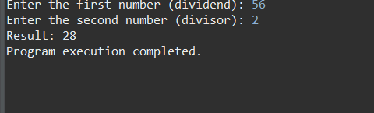

2.

package guvitask ;

public class ArrayIndexOutOfBoundsExample { public static void main(String[] args) {

int[] numbers = {1, 2, 3};

try {

System.***out***.println("Accessing index 3: " + numbers[3]);

} catch (ArrayIndexOutOfBoundsException e) {

System.***out***.println("Error: Array index out of bounds. Valid indices are from 0 to " + (numbers.length - 1) + ".");

}

System.***out***.println("Program continues after handling ArrayIndexOutOfBoundsException.");

}

} OUTPUT:

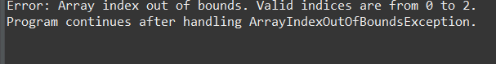

3.

package guvitask ;

class InvalidAgeException extends Exception { public InvalidAgeException(String message) {

super(message);

}

}

public class CustomExceptionExample {

public static void validateAge(int age) throws InvalidAgeException { if (age < 18) {

throw new InvalidAgeException("Age must be 18 or above. Invalid age entered: " +

age);

} else {

System.***out***.println("Age is valid: " + age);

}

}

public static void main(String[] args) {

java.util.Scanner scanner = new java.util.Scanner(System.***in***); try {

System.***out***.print("Enter your age: "); int age = scanner.nextInt();

*validateAge*(age);

} catch (InvalidAgeException e) { System.***out***.println("Error: " + e.getMessage());

} catch (Exception e) {

System.***out***.println("Error: Invalid input. Please enter a valid integer.");

} finally { scanner.close();

System.***out***.println("Program execution completed.");

}

}

}

OUTPUT:

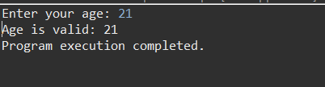

4.

package guvitask ; import java.io.File;

import java.io.FileNotFoundException; import java.util.Scanner;

public class FileExceptionHandlingExample { public static void main(String[] args) {

Scanner consoleScanner = new Scanner(System.***in***); try {

System.***out***.print("Enter the file name to read: "); String fileName = consoleScanner.nextLine(); File file = new File(fileName);

Scanner fileScanner = new Scanner(file); System.***out***.println("File Contents:"); while (fileScanner.hasNextLine()) {

System.***out***.println(fileScanner.nextLine());

}

fileScanner.close();

} catch (FileNotFoundException e) {

System.***out***.println("Error: File not found. Please ensure the file exists and try again.");

} catch (Exception e) {

System.***out***.println("An unexpected error occurred: " + e.getMessage());

} finally { consoleScanner.close();

System.***out***.println("Program execution completed.");

}

}

}

OUTPUT:

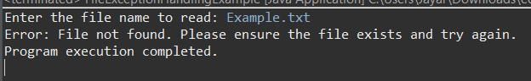

5.

package guvitask ;

import java.util.ArrayList;

public class RemoveAllElements { public static void main(String[] args) {

ArrayList<String> stringList = new ArrayList<>(); stringList.add("Apple");

stringList.add("Banana"); stringList.add("Cherry"); stringList.add("Date"); stringList.add("Elderberry");

System.***out***.println("ArrayList before removal: " + stringList); stringList.clear();

System.***out***.println("ArrayList after removal: " + stringList);

}

}

OUTPUT:



6.

package guvitask ; import java.util.TreeMap;

public class EmployeeTreeMap {

public static void main(String[] args) {

TreeMap<Integer, String> employeeMap = new TreeMap<>();

employeeMap.put(101, "John"); employeeMap.put(102, "Alice"); employeeMap.put(103, "Bob"); employeeMap.put(104, "David"); employeeMap.put(105, "Eva");

System.***out***.println("Employee Names in Alphabetical Order:"); employeeMap.values().stream()

.sorted()

.forEach(name -> System.***out***.println(name));

}

}

OUTPUT:

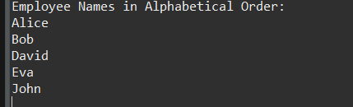

7.

package guvitask ;

import java.util.ArrayList; import java.util.List; public class ListToArray {

public static void main(String[] args) { List<String> fruitList = new ArrayList<>(); fruitList.add("Apple"); fruitList.add("Banana"); fruitList.add("Cherry"); fruitList.add("Date"); fruitList.add("Elderberry");

String[] fruitArray = new String[fruitList.size()];

fruitList.toArray(fruitArray); System.***out***.println("Array elements:"); for (String fruit : fruitArray) {

System.***out***.println(fruit);

}

}

}

OUTPUT:

